2025
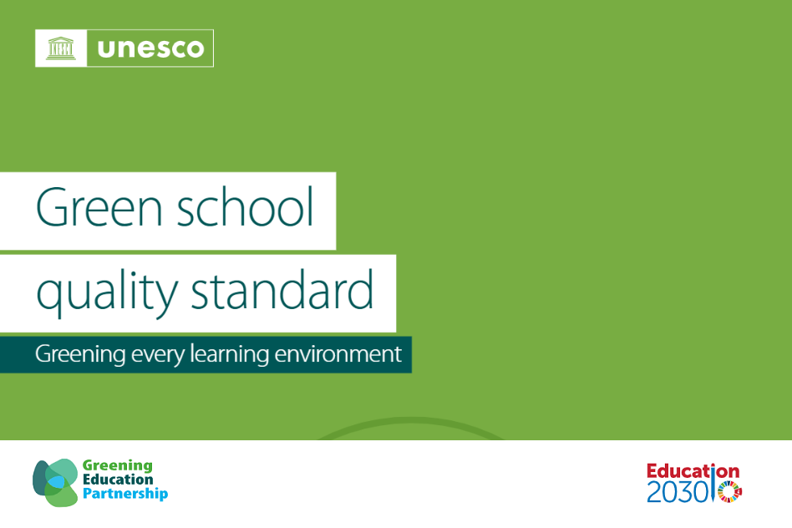

Secondary Skills and Knowledge Framework

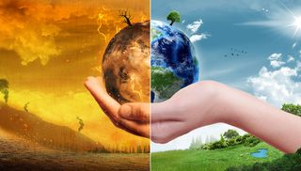

Understanding the science
By the end of Year 9 | By the end of Year 11
- I can clearly explain that burning of fossil fuels is the main cause of today’s climate change  - I am familiar with some current data findings and the possible implications of these for levels of heating in the future  - I know a range of greenhouse gases  - I can suggest a low carbon/zero carbon alternatives to a wide variety of activities which cause climate change  - I appreciate the importance of trees, forests, and mangroves in removing CO2 from the air, while also understanding their various benefits to humans and their role as habitats  - I am developing systems thinking and I am able to explain how patterns of human consumption link to climate change  - I can explain the connections between climate patterns and biodiversity.  - I can explain what a carbon footprint is and practical strategies for reducing it  - I can calculate my own carbon footprint  - I know products or industries, globally and in my region, which give rise to a high or low carbon footprint  - I understand the concept of an ecological footprint and earth overshoot day  - I can discuss the advantages and disadvantages of renewable energy sources (e.g. solar power and wind power are intermittent since they depend on the time of day and weather conditions, respectively), and I am able to match them to uses (e.g. solar for electricity and some heating purposes)  - I can evaluate energy use in my home area in terms of renewability.  - I can describe the role of the oceans in storing carbon.  - I can explain why avoiding and reducing the amount of waste is always a top priority.  - I can explain and compare the assumptions of the linear economy model and those of the circular economy model.  - I can provide examples of circular behaviours during each stage of the consumption process (for example, upcycle an item at the end of its original life – an old broken drawer can be repaired and converted to an under-bed storage box).  - I know how the water cycle is affected by global warming, e.g. evaporation from oceans is increased. Weather patterns are affected by changing temperatures leading to more flooding and drought.  - I know the El Niño cycle in the Pacific Ocean affects weather patterns globally.  - I understand fresh water is a scarce resource, dependent on the water cycle. Domestic water supplies often require treatment to remove infectious organisms and pollution from agriculture/industry/waste disposal/salination. Techniques exist for producing fresh water by desalination but require energy, often from fossil fuels  - I can explain how sustainable food is grown or produced in ways that promote healthiness as well as positive environmental and social impacts.  - I can describe how individual habits of eating influence the climate and exhaust the planet’s life support systems. | - I know the range of greenhouse gases, their respective levels of impact and how they are created  - I understand the possible ways different GHGs may be reduced.  - I understand the concept of carbon capture  - I know there are uncertainties in climate science and that science uses models to predict most probable outcomes e.g. when tipping points may be reached; how ocean currents will change  - I can explain how carbon sinks may be damaged and how they can be nurtured  - I can use permaculture principles to imagine future norms.  - I understand the pros and cons of ‘carbon offsetting’  - I can compare my lifestyle to other lifestyles globally and historically

Impact of climate change
By the end of Year 9 | By the end of Year 11
- I can explain current major impacts of climate change on humans locally and across the world  - I am aware that the global average temperature rise is accelerating and understand a range of impacts this may have on the environment, humans, wildlife and plant life  - I am familiar with a range of climate feedbacks and understand their significance  - I can explain current impacts of climate change on ecosystems locally and across the world including significant biodiversity loss and extinctions of species.  - I can identify different future scenarios for humans, species and ecosystems, and connect these projections with different levels of additional heating  - I can describe how a variety of species in a given ecosystem helps it to recover its function when under stress.  - I can identify human-induced irreversible changes in the natural environment that led to the extinction of species, and use this information to advocate for changed human behaviour in the present  - I can cite evidence that rising temperatures are melting polar ice and glaciers, affecting habitats and causing sea level rise, together with increased salinity of drinking water in some coastal regions  - I understand effects on sea life of increased acidity due to dissolved CO2  - I can explain the direct impact of climate conditions, including seasonal variations and extreme weather events, on food production processes.  - I can explain the significance of biodiversity in food production, particularly the essential impact of pollinators such as bees in the cultivation of fruits and vegetables.  - I can evaluate the environmental consequences of industrial farming practices, including the emission of GHGs through pesticide and fertilizer use, overexploitation of soil, vast monocultures and their implications for biodiversity and climate.  - I can identify that food security is at risk around the globe due to biodiversity crisis and climate change impacts  - I know a variety of conflicts could arise because of climate change | - I can explain current trends in emissions  - I can summarize current actions being taken at regional, national and international levels to reduce greenhouse gas emissions and boost carbon sinks in response to the current situation  - I am familiar with current targets and predictions for achieving carbon emission reduction targets  - I can explain key climate feedbacks in detail e.g. permafrost melt, deforestation, ocean warming  - I can discuss risks associated with different global responses and their possible effectiveness  - I am aware of geoengineering options and their possible effectiveness and/or drawbacks  - I can explain in detail the impact of climate change on a range of species and ecosystems and the potential for recovery  - I can give examples of technologies that may be deployed to help species and ecosystems adapt to climate change  - I can compare various farming methods, including organic farming, small scale farming, agroforestry and permaculture, in terms of their effects on biodiversity and climate resilience, highlighting the importance of local knowledge and sustainable practices.  - I can give several examples of expected impacts of global heating on human health, migration, food security, water supply

Young people as changemakers
By the end of Year 9 | By the end of Year 11
- I understand that anxiety, frustration, anger, numbness are some of the normal responses to understanding climate change  - I can discuss my own and others’ feelings in connection with climate change  - I can use a range of strategies to reduce anxiety and to develop positivity and a feeling of empowerment  - I can name and explain the benefits of a range of low / zero-carbon alternatives  - I am beginning to be able to use scientific evidence to evaluate different opinions/points of view  - I understand vested interests can significantly shape arguments.  - I can describe how urbanization, mechanization and a human preference for convenience and comfort have increased the distance between humans and nature.  - I can explain why influencers and other inspiring figures in modern societies may not always promote degrowth and increase of contact with natural environments  - I am developing and applying critical media literacy skills to climate media found on social media.  - I can advocate for the economic and environmental benefits of responsible circular behaviours  - I understand that there is often a contradiction between people’s awareness of the problem and people changing their behaviour and can explain some of the reasons for this  - I understand that awareness of the problem does not always lead to action, and I have begun to explore some of the reasons why.  - I understand why climate action is important at all levels, locally, nationally and globally, through governments, businesses and particular groups and individuals  - I can identify actions I can take personally and with a group of which I am part  - I am familiar with the most recent intergovernmental agreement on climate action, its main points and different views on its potential effectiveness  - I can describe a range of examples of successful collective actions and understand why they may have been successful  - I am becoming aware of key permaculture principles | - I know how to find evidence-based information about a range of options for climate mitigation and adaptation, now and in the future  - I can confidently articulate connections between technological, social, ethical and political possibilities  - I can use permaculture principles to design my own concepts for future economies, lifestyles etc.  - I understand and can debate the complex aspects of choice in modern life such as long-haul flights and car ownership  - I understand the distinction between zero emissions and net-zero emissions  - I demonstrate self-awareness in my lifestyle choices, including of internal contradictions.  - I can empathise with people whose choices are different from my own.  - I can define global citizenship, understanding people’s roles and responsibilities as global citizens within interconnected (natural, human, built) systems that are threatened by climate impacts  - I can begin to identify which realistic future scenarios may relate to which alternative course of action on emissions reduction / carbon drawdown / adaptation  - I can offer opinions about the aims and methods of movements that are responding to aspects of the climate emergency  - I understand arguments for and against government legislative responses, including cost and limiting individual freedoms  - I can begin to visualise and compare an optimistic and a most likely scenario in 2050 and 2100

Climate Justice
By the end of Year 9 | By the end of Year 11
- I understand the concept of ‘Climate Justice’.  - I can discuss the differential impacts of climate change, recognizing that vulnerable groups are disproportionately affected due to factors such as geography, gender, race, immigration status and socio-economic status.  - I understand there are a range of different perspectives to climate change including those of indigenous communities, spiritual / religious perspectives, people of colour, the global south etc, if possible, directly, or at least in the words of people from those communities  - I understand how different viewpoints might lead to different behaviours  - I can describe how some groups have relatively more power, choices, agency in the context of climate adaptation, and that this is unfair because this difference is largely determined by circumstances and structures and not because they deserve these privileges more than those with less power, choices, and agency.  - I can evaluate how certain groups – locally, nationally and globally – have relatively less power, choices, agency, and resources to cope or to adapt, and explain how this is unjust because this difference is determined by poverty and inequalities and not because they don’t deserve more.  - I can list and categorize the different costs that the impacts of climate change can have (e.g. financial, emotional, psychological, social, cultural, environmental, etc.).  - I know which perspectives on sustainability and climate change I am personally drawn to and why. | - I can explain my own opinions on climate justice proposals such as climate reparations  - I can explain the idea of a ‘just transition’  - I can confidently evaluate a range of ways of understanding the relationship between Earth and humanity from different perspectives  - I can begin to suggest how prevailing human mindsets might need to change or develop in response to the climate emergency.  - I have begun to investigate how people, communities, and countries that experience a higher burden of cost need more support and assistance to recover from these costs  - I can define climate change mitigation and adaptation, understand the differences between them, and explain how they are used to address climate disasters.

